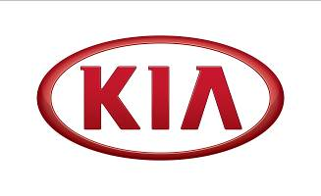

ALBERT BIERMANN

President of Hyundai-Kia Vehicle Test & High-Performance Development
Born on May 28, 1957, Mr. Biermann received a Master’s degree in Mechanical Engineering at Rheinisch-Westfälische Technische Hochschule Aachen in Germany.
Mr. Albert Biermann joined Hyundai Motor Group as Executive Vice President and Head of Vehicle Test & High Performance Development in April 2015. Based at the company’s R&D Centre in Namyang, Korea, Mr. Biermann is leading the development of new high performance Hyundai and Kia models, as well as overseeing engineering projects relating to ride and handling, safety, reliability, and the mitigation of NVH (noise, vibration and harshness).
Most recently, Mr. Albert Biermann has been promoted to President and Head of Vehicle Test & High-Performance Development at Hyundai Motor/Kia Motors, effective from 8 January, 2018.
- Mr. Biermann first joined BMW in 1983 as an Engineer in Suspension Testing
- In 1986 and 1987, he worked as a Test Engineer at BMW Motorsport
- From 1988 to 1993, he was the Team Manager for Vertical Dynamics in Chassis systems Development
- By 1994, he had been appointed as Product Development Manager in BMW of North America
- From 1997 until 2000, he was Director of Chassis, Drivetrain, Electric systems Development at BMW M GmbH
- In 2000, Mr. Biermann was back in Germany as Technical Director of Sports and Touring Cars at BMW Motorsport
- In 2003, he was appointed to Overall Project Manager for BMW X5 and BMW X5/X6M at BMW AG
- Between 2008 – 2015, he held the role of Vice President Engineering BMW M Automobiles and BMW Individual at BMW M GmbH, Germany, before he joined Hyundai Motor Group as Executive Vice President and Head of Vehicle Test & High Performance Development in April 2015
- As of 8 January 2018, he was promoted to President for Hyundai-Kia Vehicle Test & High-Performance Development.

