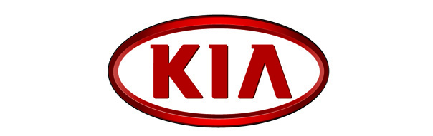

GREGORY GUILLAUME

Chief Designer
Kia Motors Europe

- Born 1969 in France
- 1991: Art Center College of Design (Europe) BA in Transportation Design
- 1992-1994: Audi – Designer
- 1994-1995: VW – Senior Designer Exterior
- 1995-1996: VW Concept Design Studio – Exterior Chief Designer
- 1996-1998: VW California Studio – Project Leader
- 1999-2003: VW Group Advanced Design Studio, Sitges, Spain – Director
- 2003-2004: VW – Design Management (Special Projects and Advanced Design)
- 2005-present: Kia Design Center Europe – Chief Designer

Production cars
- 2007 pro_cee’d Exterior
- 2009 Venga Exterior
- 2010 Cadenza Exterior
- 2010 Optima Exterior
- 2010 Sportage Interior
- 2011 Picanto Interior
- 2011 Rio Interior
- 2012 cee’d Exterior and Interior
- 2012 cee’d Sportswagon Exterior
- 2012 pro_cee’d Exterior
- 2012 Carens Exterior
- 2013 Cadenza Exterior – Facelift
- 2013 pro_ceed GT Exterior and Interior
- 2013 cee’d GT Exterior and Interior
- 2013 Optima Exterior and Interior – Facelift
- 2013 Soul Interior
- 2013 Sorento Interior
- 2015 cee’d Exterior – Facelift
- 2015 GT line for: pro_cee’d / cee’d / cee’d Sportswagon

Concept cars
- 2006 cee’d
- 2006 pro_cee’d
- 2007 ex_cee’d
- 2007 kee
- 2008 Soul Diva, Soul Burner and Soul Searcher
- 2008 No3
- 2010 POP
- 2011 GT
- 2013 provo
- 2013 niro
- 2015 Sportspace

Design Awards

- Venga (2009)
- 2011 red dot Design Award Winner
- 2011 iF Design Award Winner

- Optima (2010)
- 2011 red dot Design Award ‘Best of the Best’
- 2011 iF Design Award Winner
- 2011 abc Design Award Winner
- 2011 Good Design Award Winner

- Sportage (2010)
- 2011 red dot Design Award Winner
- 2011 iF Design Award Winner
- 2011 abc Design Award Winner
- 2011 Good Design Award Winner

- Kia Design Identity
- 2011 abc Design Award ‘Best of the Best’

- GT Concept (2011)
- 2012 red dot Design: Award Winner

- Rio (2011)
- 2012 red dot Design Award Winner
- 2011 abc Design Award Winner

- Picanto (2011)
- 2012 red dot Design Award Winner

- pro_cee’d (2012)
- 2013 red dot Design Award ‘Best of the Best’
- iF Design Award Winner

- cee’d (2012)
  - 2013 German Design Award
  - 2013 red dot Design Award Winner
  - 2012 abc Design Award Winner

- cee’d Sportswagon (2012)
  - 2013 red dot Design Award Winner

- Carens (2012)
- 2013 red dot Design Award Winner

- Provo Concept (2013)
- 2014 abc Design Award ‘Best of the Best’

- Kia Design Team
- 2014 abc Design Award ‘Design Team of The Year’

- Soul (2013)
- 2014 red dot Design Award Winner
- 2014 iF Design Award Winner
- 2015 iF Design Award Winner for Soul EV

- Sorento (2014)
- 2011 iF Design Award Winner
- 2011 red dot Design Award Honorable Mention

